IEEE 802.11 Distribution System

1. 802.11 is suitable for ad-hoc configuration of nodes that may or may not be able to communicate with all other nodes
2. Nodes are free to move around
3. The set of directly reachable nodes may change over time.
4. To deal with this mobility and partial connectivity:
   1. 802.11 defines additional structures on a set of nodes
   2. Instead of all nodes being created equal,
      1. Some nodes are allowed to room and some are connected to a wired network infrastructure, ther are called Access points (AP) and they are connected to each other by a so-called **distribution system**

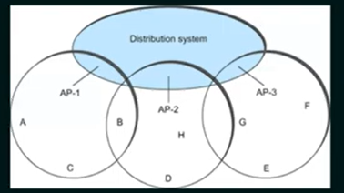

1. Although two nodes can communicate with each other if they are within reach of each other, the idea behind this configuration is
   1. Each node associates itself with one access point
   2. For node A to communicate with node E, A first send a frame to its AP-1 which forwards the frame across the distribution system to AP-3, which finally transmits the frame to E.

How do the nodes select their AP?

1. The technique for selecting an AP is called **scanning**
   1. The node sendsa Probe frame
   2. All APs within reach reply with a Probe response frame
   3. The ndoe selects one of the access points and sends that AP an Association Request frame.
   4. The AP replies with an Association Response frame.

Node mobility

1. Consider the case when node C moves from the cell serviced by AP-1 to the cell serviced by AP-2.
2. As it moves, it sends Probe frames, which eventually result in Probe Responses from AP-2
3. At some point, C prefers AP-2 over AP-1 and so it associates itself with that access point. This is called **active scanning**, since the node is actively searching for an access point.

Passive Scanning

1. APs also periodically send a Beacon frame that advertises the capabilities of the access point these include the transmission rate supported by the AP:
   1. This is called passive scanning
   2. A node can change to this AP based on the Beacon frame simply by sending it an Association request frame back to the access point.